

**Mini Project Report**

**of**

**Compiler Design Lab (CSE 3161)**

**PARSER FOR HTML USING FLEX AND BISON**

**SUBMITTED**

**BY**

**HARSHIT HANSRAJ (210905164)/27**

**LAXYA PAHUJA (210905166)/28**

**VISWATARA KALAMSETTY (210905170) / 29**

**TAKSH KOTHARI (210905338) / 54**

**CSE- ‘A’**

**Department of Computer Science and Engineering**

**Manipal Institute of Technology, Manipal.**

**November 2023**

**TABLE OF CONTENTS**

CHAPTER 1: ABSTRACT

CHAPTER 2: PROBLEM STATEMENT

CHAPTER 3: ALGORITHM

CHAPTER 4: METHODOLOGY

CHAPTER 5: IMPLEMENTATION

CHAPTER 6: REFERENCES

**ABSTRACT**

Our project focuses on creating a parser for the Hypertext Markup Language (HTML). HTML controls how information is presented and organized online in today's digital landscape. Therefore, strong tools that can parse, comprehend, and analyze HTML code are becoming more and more important as the demand for web applications rises. Our goal is to convert unstructured HTML code into a structured representation by using grammar definitions and parsing techniques. This will make it easier for browsers and other web-based apps to understand and render the code.

**PROBLEM STATEMENT**

Our project's main focus is on creating a compiler designed especially for HTML. We aim to construct a system that thoroughly analyzes HTML syntax, validates its structure, and generates a representation that is suitable for interpretation by web browsers or other applications.

The key challenges addressed are:

**Parsing Complexity:** HTML requires a strong parsing system in order to correctly break down its components because of its hierarchical structure, which includes nested tags, attributes, and content.

**Error Handling:** HTML code errors can result in rendering problems or functional inconsistencies. So, to find and fix problems quickly, developers must provide efficient error reporting and detection systems.

**Optimization and Efficiency:** Accurate translation is only possible with efficient code generation, which also helps web applications run more smoothly and make better use of their resources.

**ALGORITHM**

1. **Lexical Analysis:** Define tokens using regular expressions to recognize HTML elements, attributes, and content. Categorize tokens such as DOCTYPE, tags, text, etc., based on the matched patterns.
2. **Syntactic Parsing:** Use defined grammar rules to identify HTML elements, open/close tags, and their attributes. Construct a hierarchical representation of HTML elements using parsing logic.
3. **Semantic Processing:** Validate the structure and attributes of parsed HTML elements to ensure adherence to HTML standards. Detect and report errors related to incorrect syntax or semantic inconsistencies.
4. **Code Generation:** Display recognition messages to indicate successful identification of HTML components during parsing.

**METHODOLOGY**

**Lexer Implementation:** Utilize patterns defined in the code to identify and categorize tokens such as DOCTYPE, tags, text, etc.

**Parser Development:** Use Bison-like parsing rules to create grammar structures for HTML elements, tags, attributes, and content.

**Semantic Analysis:** Validate the syntax and structure of HTML elements, checking attributes for correct usage and adherence to standards.

**Code Generation:** Present recognition messages at various stages of parsing to indicate successful identification of HTML components.

**Grammar:**

document -> html_element

html_element -> open_tag content close_tag

| open_tag close_tag

open_tag -> '<' tag_name attribute_list '>'

close_tag -> '</' tag_name '>'

tag_name -> ID

attribute_list -> attribute attribute_list

| ε

attribute -> ID '=' STRING

content -> text content_prime

| html_element content_prime

| ε

content_prime -> content

| ε

text -> TEXT

ID -> [a-zA-Z][a-zA-Z0-9]*

STRING -> "([^"])*"

TEXT -> .+

**IMPLEMENTATION**

In this section, we will discuss the results obtained from the execution of the lexer and parser programs and provide an analysis of the program's behaviour.

**Sample Input:**

<!DOCTYPE html>

<html>

<head>

<title>

Hello

</title>

<meta >

</head>

<body>

<h1>

Welcome to my Sample HTML Page

</h1>

<p>

This is a paragraph of text.

</p>

<ul>

<li>

hi

</li>

<li>

hi

</li>

<li>

hi

</li>

</ul>

</body>

</html>

**Code:**

**parser.y:**

%{

#include <stdio.h>

#include <stdlib.h>

int yylex();

int yyerror(char* msg);

extern FILE* yyin;

%}

%token DOCTYPE HTML_BODY_OPEN HTML_BODY_CLOSE

%token HEAD_OPEN HEAD_CLOSE TITLE_OPEN TITLE_CLOSE META

%token BODY_OPEN BODY_CLOSED OPEN_TAG CLOSE_TAG TEXT

%token DIGIT EQUAL QUOTED_STRING UNQUOTED_STRING CB

%%

html_doc: DOCTYPE html_body { printf("HTML Document recognized!\n"); }

;

html_body: HTML_BODY_OPEN head body HTML_BODY_CLOSE { printf("HTML Body recognized!\n"); }

;

head: HEAD_OPEN title meta HEAD_CLOSE { printf("Head recognized!\n"); }

| /* ε */ { printf("Empty Head recognized!\n"); }

;

title: TITLE_OPEN TEXT TITLE_CLOSE { printf("Title recognized!\n"); }

| TITLE_OPEN TITLE_CLOSE

;

meta: META attributes CB { printf("Meta recognized!\n"); }

|

;

body: BODY_OPEN content BODY_CLOSED { printf("Body recognized!\n"); }

;

content: element content { printf("Element content recognized!\n"); }

| TEXT content { printf("Text content recognized!\n"); }

| /* ε */ { printf("Empty content recognized!\n"); }

;

element: open_tag content close_tag { printf("Element recognized: %s\n", yylex); }

;

open_tag: OPEN_TAG { printf("Open tag recognized!\n"); }

;

close_tag: CLOSE_TAG { printf("Close tag recognized!\n"); }

;

attributes: attribute attributes { printf("Attributes recognized!\n"); }

| /* ε */ { printf("Empty attributes recognized!\n"); }

;

attribute: attr_name EQUAL attr_value { printf("Attribute recognized!\n"); }

;

attr_name: TEXT { printf("Attribute name: %s\n", yylex); }

;

attr_value: QUOTED_STRING { printf("Quoted attribute value: %s\n", yylex); }

| UNQUOTED_STRING { printf("Unquoted attribute value: %s\n", yylex); }

;

%%

int yyerror(char* msg)

{

printf("Error: %s\n", msg);

return 1;

}

int main(int argc, char** argv)

{

yyin = fopen(argv[1], "r");

if (!yyin)

{

yyerror("File Error\n");

return 1;

}

yyparse();

fclose(yyin);

return 0;

}

**lexer.l:**

%{

#include "parse.tab.h"

%}

%%

"<!DOCTYPE html>" { return DOCTYPE; }

"<html>" { return HTML_BODY_OPEN; }

"</html>" { return HTML_BODY_CLOSE; }

"<head>" { return HEAD_OPEN; }

"</head>" { return HEAD_CLOSE; }

"<title>" { return TITLE_OPEN; }

"</title>" { return TITLE_CLOSE; }

"<body>" { return BODY_OPEN; }

"</body>" { return BODY_CLOSED; }

"<meta" { return META; }

">" { return CB; }

"<"([a-zA-Z][a-zA-Z0-9_]*)">" { return OPEN_TAG; }

"</"([a-zA-Z][a-zA-Z0-9_]*)">" { return CLOSE_TAG; }

[ \t\n] ; // ignore whitespaces

[a-zA-Z][a-zA-Z0-9_ .]* { return TEXT; }

[0-9]+ { return DIGIT; }

"=" { return EQUAL; }

\"[^\"] { return QUOTED_STRING; }

[^ \t\n]+ { return UNQUOTED_STRING; }

%%

int yywrap() {

return 1;

}

**Execution of Program:**  
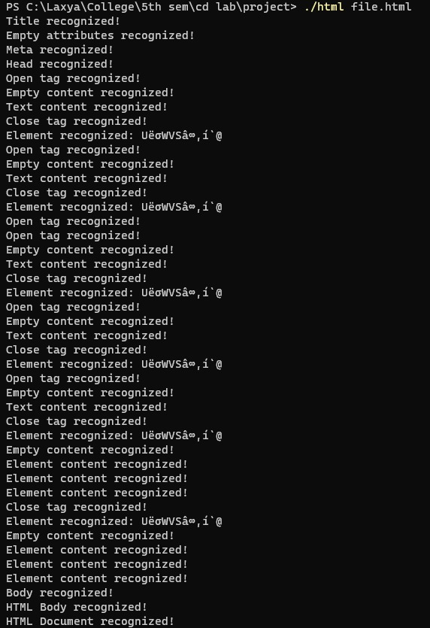

**REFERENCES**

1. Compilers – Principles, Techniques & Tools (Second Edition) – Alfred V. Aho, Monica S. Lam, Ravi Sethi, Jeffery D. Ulmann
2. Compiler Design Lab Manual, Manipal Institute of Technology